Vacation Planner Application
  - Design Document
Author: Juan Gonzalez
Course: D424 Software Engineering Capstone
Date: 06/24/2026
Table of Contents
System Overview 2
Architecture Overview 2
Architecture Diagram 3
Class Diagram 4
Web App Hosted with HTML Code 7
GitLab Repository 7
User Guide for Setting Up and Running the Application (Maintenance Guide) 7
System Requirements 7
Installation Instructions 7
Running the Application 7
Option A: Physical Device 7
Option B: Emulator 8
Project Structure 8
Database Maintenance 8
Alerts & Notifications 8
Updating Dependencies 8
Troubleshooting 9
User Guide for Running the Application 9
Introduction 9
Launching the Application 9
Home Screen (Vacation List Screen) 9
Adding a Vacation 10
Viewing and Editing a Vacation 10
Adding an Excursion 10
Editing or Deleting an Excursion 11
Viewing the Vacation Report 11
Alerts and Reminders 11
Show Summary 11
Excursions Search Function 12
Exiting the Application 12

System Overview
The Vacation Planner application is a full-stack Android mobile solution designed to help users manage their vacations, excursions, budgets, and reminders. The system provides:
- Vacation creating and editing
- Excursion tracking
- Budget management
- Automated alerts and reminders
- A detailed report screen
- Persistent local storage using Room
- A modern UI built with Jetpack Compose
The application follows the MVVM architecture, ensuring clean separation of concerns and long-term maintainability.

Architecture Overview
The Android Application is structured into modular packages that clearly separate concerns:
- UI Layer (Jetpack Compose): Displays screens, collects user input, and reacts to state changes.
- ViewModel: Holds UI state, performs validation, and communicates with repositories.
- Repository: Abstract data operations and mediates between ViewModels and the database.
- Database: Stores vacations and excursions using DAOs and entities.
- Entities: Holds data models
- Utilities: Provides shared logic for data formatting, sorting, and budget calculations.

This architecture ensures scalability, testability, and clean separation of responsibilities.

Architecture Diagram

Class Diagram
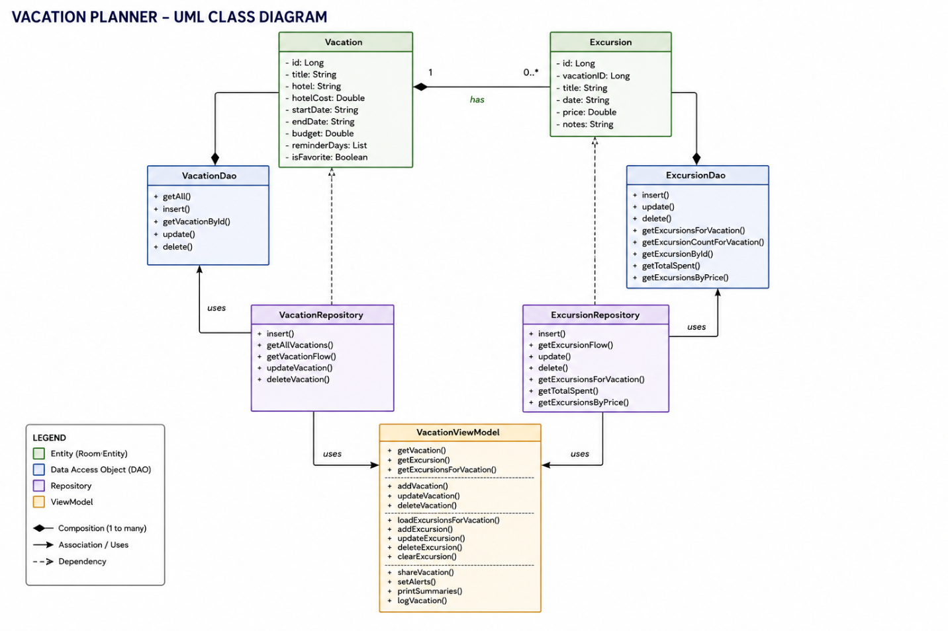

Web App Hosted with HTML Code
This project is a native Android mobile application built with Kotlin and Jetpack Compose.
A hosted web application and HTML code are not applicable for this implementation.

GitLab Repository
GitLab Repository URL: WGU GitLab Environment / Student Repos / jgonz270 / D424 Software Engineering Capstone · GitLab
Branch/Version: working_branch
Commit Hash for Submitted Version: def1b8d95e205d5fe55e8e0b004413d2121ef6bf

User Guide for Setting Up and Running the Application (Maintenance Guide)

System Requirements
- Android Studio (Flamingo or newer)
- Android SDK 24+
- JDK 11 or higher
- Windows, macOS, or Linux
- Android device for physical testing or emulator

Installation Instructions
- Clone the repository: git clone <GitLab Repository URL>
- Open the project in Android Studio
- Allow Gradle to sync automatically
- Ensure the required SDKs are installed under: Tools -> SDK Manager
- Build -> Make Project

Running the Application

Option A: Physical Device
- Enable Developer Options
- Enable USB Debugging
- Connect device via USB
- Select device from run targets
- Click Run

Option B: Emulator
- Open Device Manager
- Create a virtual device
- Select Android 12 or higher
- Click Run

Project Structure
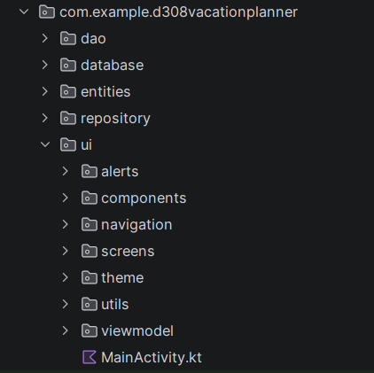

Database Maintenance
The app uses Room, which automatically creates and manages the database. To reset the database: uninstall and reinstall the app. No external configuration is required.

Alerts & Notifications
Alerts use AlarmManager and a BroadcastReceiver. If alerts do not appear, ensure notification permission is granted.

Updating Dependencies
Dependencies can be updated in:
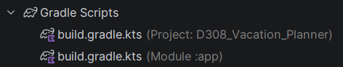
After changes, run: File -> Sync Project with Gradle Files

Troubleshooting
If app won’t build try the following:
- Run Build -> Clean Project
- Then Build -> Rebuild Project
Emulator slow or freezing:
- Enable hardware acceleration
- Use a lower resolution device
Alerts not firing:
- Check notifications permission
- Ensure device is not in battery save mode

User Guide for Running the Application

Introduction
The Vacation Planner app allows users to create, view, and manage vacations and excursions. This guide explains how to use the Vacation Planner from a regular user’s perspective.

Launching the Application
- Tap the Vacation Planner icon on the device.
- The app opens to the Vacation List Screen.

Home Screen (Vacation List Screen)
On this screen, users can:
- View all vacations saved
- Tap a vacation to open its details
- Tap the “+” button to add a new vacation
- Tap the start icon to mark a vacation as a favorite
- Tap the search bar to look up a vacation
- Filter vacations to show only favorite vacations by tapping the star near the screen title
- Sort vacations by tapping the sorting setting

Adding a Vacation
- Tap the “+” button
- Enter:
- Vacation title
- Hotel name
- Hotel cost
- Start date
- End date
- Budget
- Tap Save
Validation:
- Fields cannot be left blank
- Hotel cost and Budget need a valid number
- End date must be after start date.
- Start and End date must be entered in the right format

Viewing and Editing a Vacation
- Tap any vacation in the list
- The Vacation Details screen appears
- In the Vacation Details Screen, you can do the following:
- Edit the vacation information
- Delete the vacation
- Add excursions
- View the vacation report
- Tap Save after making changes

Adding an Excursion
- Tap a Vacation
- Tap Add Excursion
- Enter the following:
- Excursion title
- Date
- Price
Validation:
- Fields cannot be empty beside the note’s fields
- Price must be positive

Editing or Deleting an Excursion
- Tap the excursion from the list
- Modify the fields and tap Save
- Tap Delete to remove it

Viewing the Vacation Report
- Tap a Vacation
- Tap View Report
- Once you tap View Report you will see the following:
- Vacation Summary: title, hotel, dates, budget
- Excursions: list of excursions with their cost
- Budget breakdown: hotel cost, excursions, remaining

Alerts and Reminders
The app can notify users about:
- Upcoming vacations
- Excursion dates
In addition, a user can set when they want to get notified based on the reminder option they are given. They can choose from the day before the start day to seven days before the start date. To do this, the user needs to do the following:
- Tap a Vacation
- Tap when they want to get notified
- Tap Set Alerts
- Tap Save
Note: When prompted, allow Notification Permission so alerts can appear.

Show Summary
- Tap a Vacation
- Tap Show Summary Toggle
This will show the summary of the vacation including its excursions

Excursions Search Function
- Tap a Vacation
- Tap excursions search bar to look up excursions
- Optional: sort by date, title, price
If no excursion exists inside a vacation, the application will show “No excursion found”

Exiting the Application
- Press the device’s Home button
- The app saves all data automatically

